
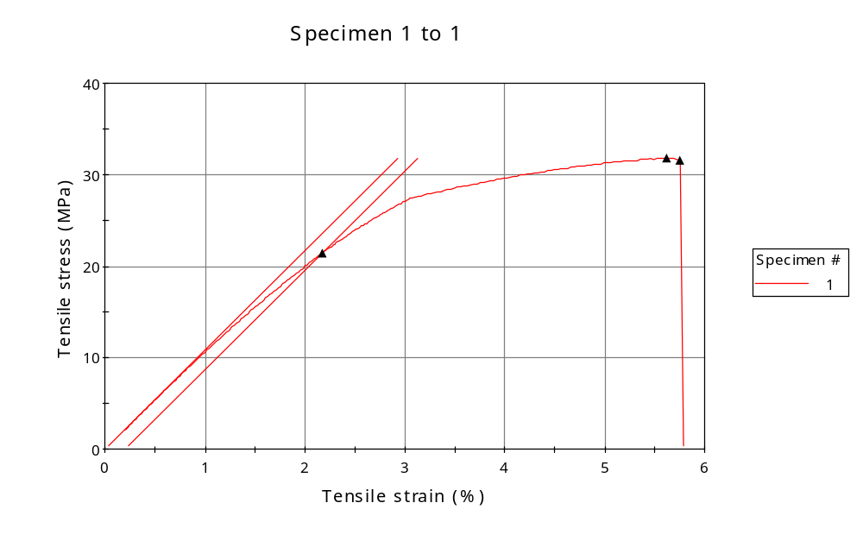
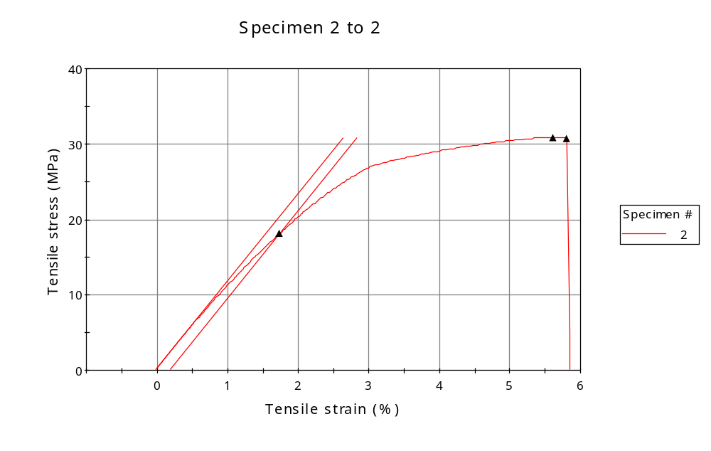
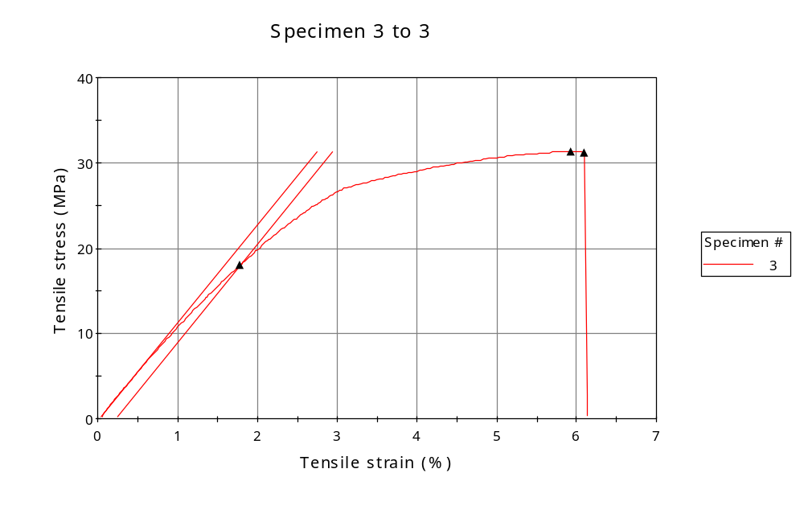
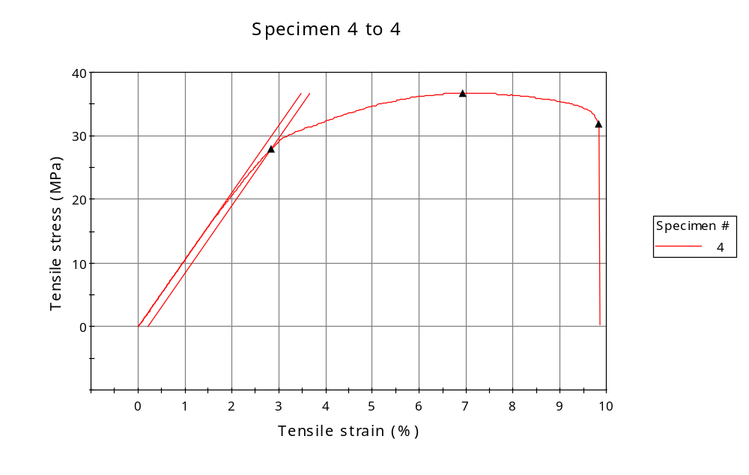
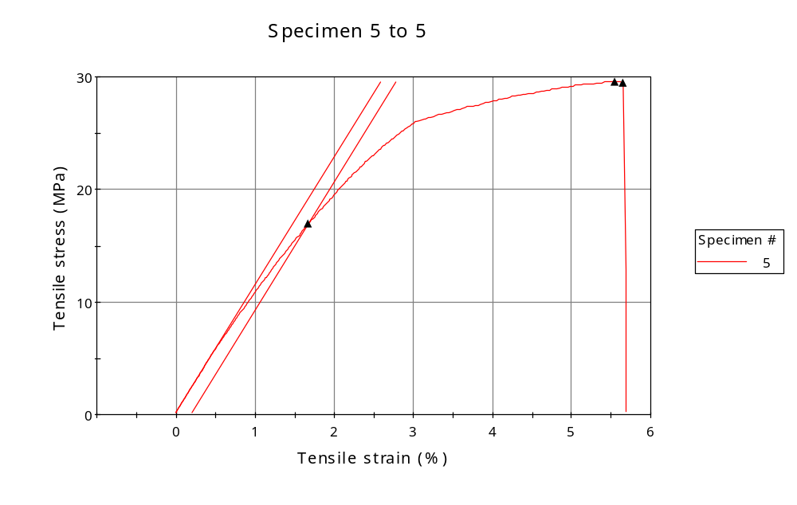
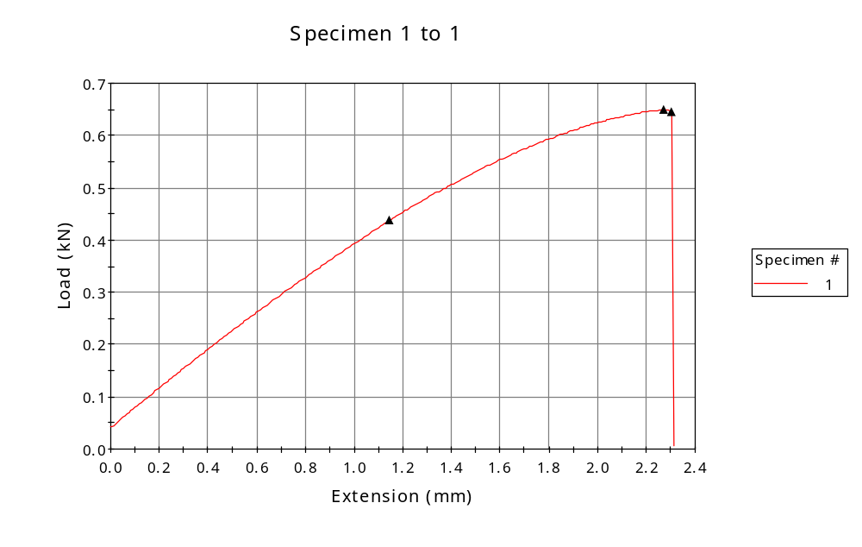
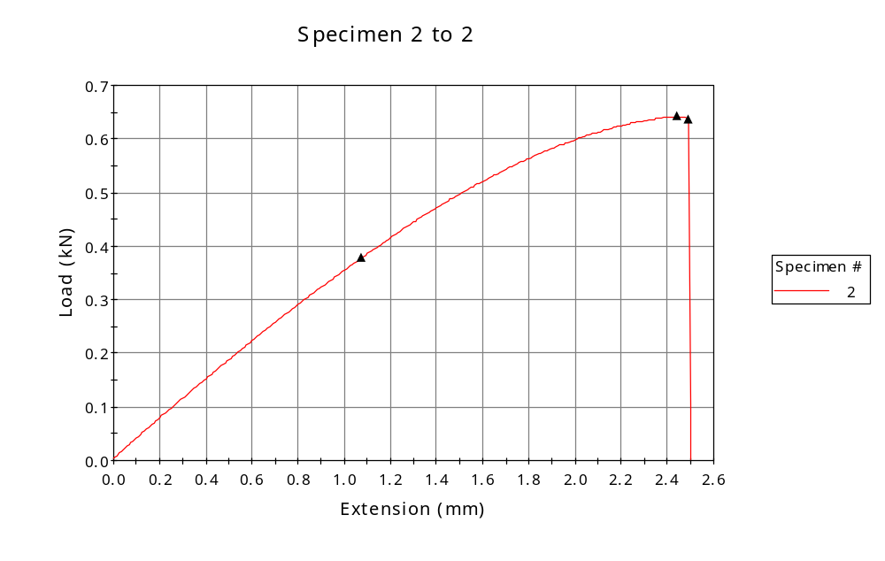
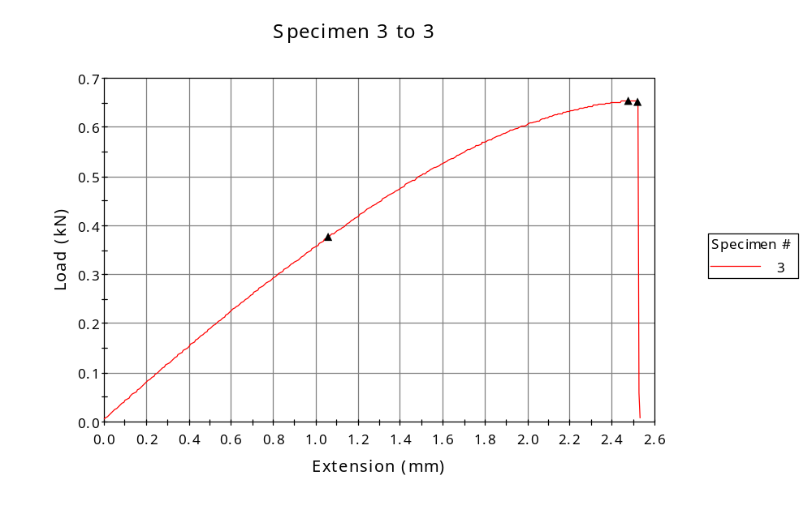
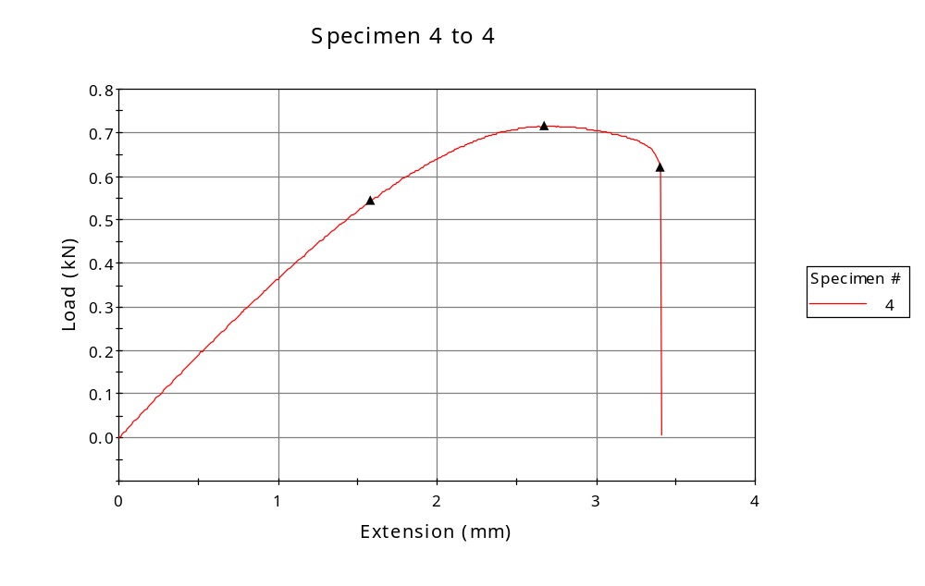
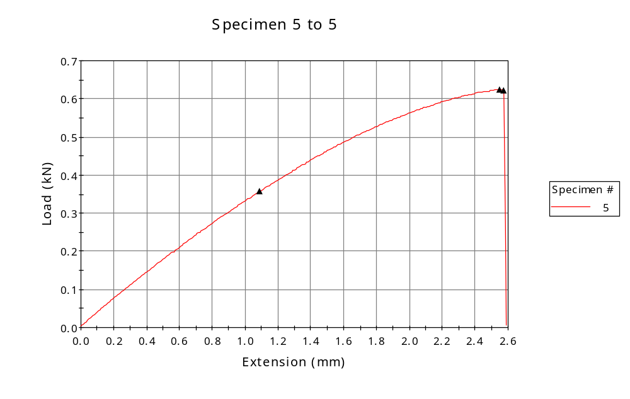

 | CP ID | Length  (mm) | Width  (mm) | Thickness  (mm) | Modulus (Automatic Young's)  (MPa)
1 | CP-FDM_ZX6_01 | 25.00 | 6.15 | 3.32 | 1089
2 | CP-FDM_ZX6_02 | 25.00 | 6.17 | 3.37 | 1160
3 | CP-FDM_ZX6_03 | 25.00 | 6.15 | 3.39 | 1151
4 | CP-FDM_ZX6_04 | 25.00 | 6.12 | 3.18 | 1060
5 | CP-FDM_ZX6_05 | 25.00 | 6.19 | 3.41 | 1136
Maximum |  | 25.00 | 6.19 | 3.41 | 1160
Minimum |  | 25.00 | 6.12 | 3.18 | 1060

 | Load at Fy ( 0.2 %) - LE  (kN) | Tensao em Fy ( 0.2 %) - LE  (MPa) | Deformacao em Fy ( 0.2 %) - LE  (%) | Forca Max  (kN) | Tensao na Forca Max - LR  (MPa)
1 | 0.438 | 21 | 2.175 | 0.649 | 32
2 | 0.378 | 18 | 1.736 | 0.642 | 31
3 | 0.376 | 18 | 1.785 | 0.653 | 31
4 | 0.544 | 28 | 2.840 | 0.715 | 37
5 | 0.357 | 17 | 1.668 | 0.624 | 30
Maximum | 0.544 | 28 | 2.840 | 0.715 | 37
Minimum | 0.357 | 17 | 1.668 | 0.624 | 30

 | Deformacao na Forca Max - LR  (%) | Forca na Forca na Quebra - LQ  (kN) | Deformacao na Forca na Quebra - LQ  (%) | Final length  (mm) | Final width  (mm)
1 | 5.627 | 0.644 | 5.761 | 119.00 | 6.82
2 | 5.610 | 0.637 | 5.810 | 119.00 | 6.82
3 | 5.931 | 0.651 | 6.098 | 119.00 | 6.82
4 | 6.930 | 0.619 | 9.830 | 119.00 | 6.82
5 | 5.551 | 0.622 | 5.651 | 119.00 | 6.82
Maximum | 6.930 | 0.651 | 9.830 | 119.00 | 6.82
Minimum | 5.551 | 0.619 | 5.651 | 119.00 | 6.82

 | Alongamento
1 | 3.76
2 | 3.76
3 | 3.76
4 | 3.76
5 | 3.76
Maximum | 3.76
Minimum | 3.76

